Writing (the second term)
Variant 1

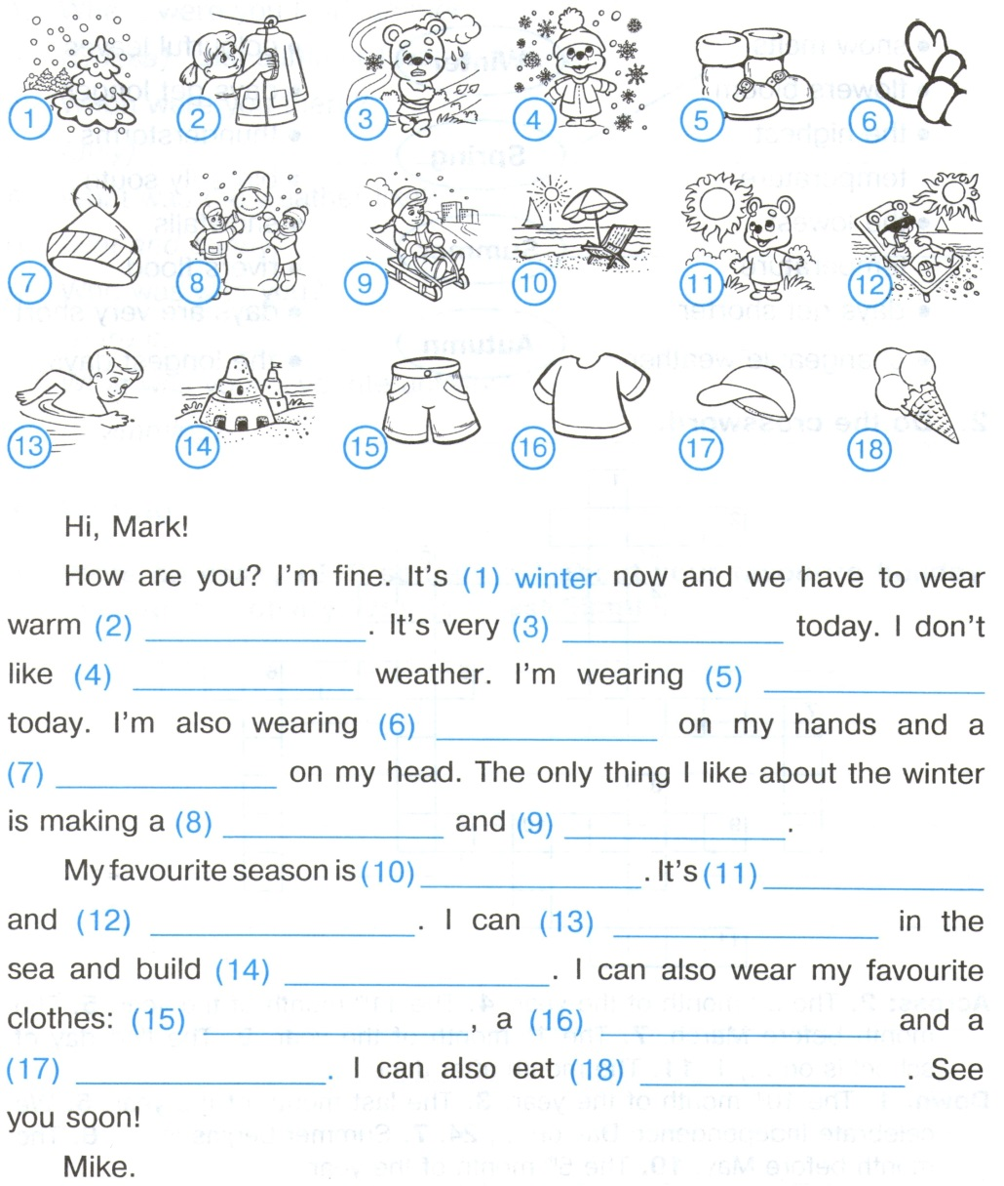
- Look at the pictures and complete the letter.

- Put the verbs in brackets into the Present Perfect. Write the interrogative and negative sentences.

- Ann ____________________________ (already / read) the newspaper.
_____________________________________________
_____________________________________________
_____________________________________________
- They ___________________________ (just / water) the plants.
_____________________________________________
_____________________________________________
_____________________________________________

- Introduce your village, finishing the given sentences.

I live in_________________________________________.
It is ____________________________________________.
It stands on ______________________________________.
There are ________________________________________
_______________________________________________________________________________________________.
There is _________________________________________
_______________________________________________.
I like ___________________________________________
_______________________________________________.

Writing (the second term)
Variant 2

- Look at the pictures and complete the letter.

- Put the verbs in brackets into the Present Perfect. Write the interrogative and negative sentences.

- We ____________________________ (already / buy) milk.
_____________________________________________
_____________________________________________
_____________________________________________
- John ___________________________ (just / visit) the UK.
_____________________________________________
_____________________________________________
_____________________________________________

- Introduce your village, finishing the given sentences.

I live in_________________________________________.
It is ____________________________________________.
It stands on ______________________________________.
There are ________________________________________
_______________________________________________________________________________________________.
There is _________________________________________
_______________________________________________.
I like ___________________________________________
_______________________________________________.

